**TaskC.1(b) Data cleaning**

**Explore Data:**

The result below shows the data for each table.

Address table:

Advertisement table:

Agent table:

Agent_office table:

Client table:

Client_wish table:

Feature table:

Postcode table: 

Property_feature table:

**Find errors:**

After exploring the data as shown above, the following checking process for detecting errors are performed as shown below.

This query is to check whether there are any duplicated records in address table.

The result shows that there are 39 addresses have duplicated records.

This query below is to check whether there are any null and illegal values in the address table.

The result shows that there are no null or illegal values in address table.

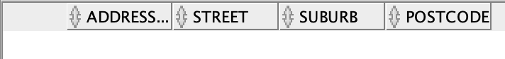

This query below is to check whether all the postcodes recorded in the address table matches the records in the Postcode table.



The result is positive, which shows no finding.



This query below is to check whether there are any duplicated records in the advertisement table.

The result shows there are no duplicated records.



This query below is to check whether there are null and illegal values in the advertisement table.

The result shows no.



This query below is to check whether there are any null and illegal values in the agent table.

The result shows there are one 0 and two negative values of salary attribute in the agent table as shown below.

This query below is to check is there any records of person Id in agent table that are not in the person table.

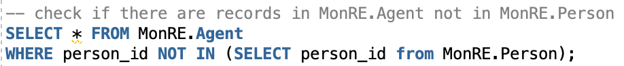

The result shows that person id 6997 is not recorded in the person table.

This query below is to check is there any records of person Id in the agent office table are not in the person table. Also, to check whether there are any records od office Id that are not recorded in the Office table.

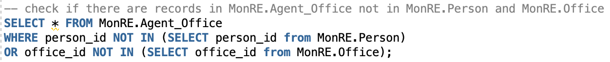

The result shows there is one record as shown below.

This query below is to check whether there are any null or illegal values in the client table.

The result shows that there is a record of maximum budget that is a negative value of -150. Besides, there are two records where the maximum budget is lower than the minimum budget.

This query below is to check whether there are any illegal values in the client wish table.

The result shows that there are no illegal values in the client wish table.

This query below is to check whether there are any records of feature code in the client wish table that are not in the feature table, and whether any records of person Id in the client wish table that are not in the person table.

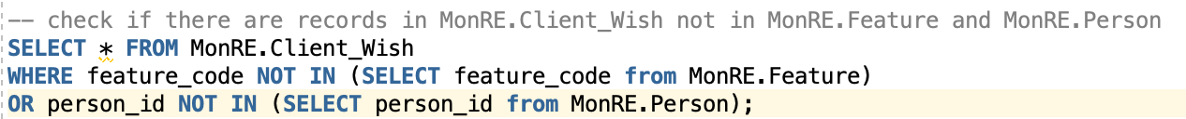

The result shows no.

This query below is to check is there are any null and illegal values in feature table.

The result shows that there are no such values.



This query below is to check whether there are any duplicated records in the feature table.

The result shows that there are no records of duplicated values.

This query below is to check whether there are any illegal and null values in the office table.

The result shows that there are no null or illegal values in the table.

This query below is to check whether there are any duplicated records in the office table.

The result shows that there are no duplicated records.

This query below is to check whether there are any illegal and null values in the person table.

The result shows no such record.



This query below is to check whether there are any duplicated records in the person table.

The result shows that there are four duplicated records for person with id 6995.

This query below is to check is there any records of address Id in the person table that are not in the address table.



The result shows that there is one record of address is not in the address table.



This query below is to check whether there are any illegal or null values in the postcode table.

The result shows that there is no such record.

This query below is to check whether there are any duplicated records in the postcode table.

The result shows that there is no such record.

This query below is to check whether there are any records of state code in the postcode table that are not in the state table.

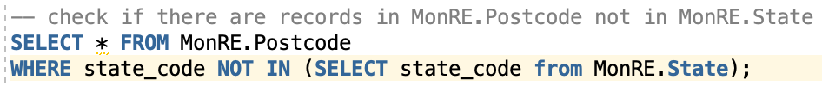

The result shows that there is no such record.

This query below is to check whether there are any illegal or null values in the property table.

The result shows that there are 1550 rows of records contains illegal or null values.

This query below is to check whether there are any duplicated records in property table.

The result shows that there are two property that have duplicated records.

This query below is to check whether there are any records of address Id in the property table that are not in the address table.



The result shows that there is no such value.



The query below is to check whether there are any illegal or null values in the property advert table.

The result shows that there is no such value.

The query below is to check whether there are records of property_id in the property advert table that are not from the property table. And to check whether there are any records of advert_id in the property advert table that are not from the advertisement table. Also, to check whether there are any records of agent_person_id in the propery advert table that are not in the agent table.



The result shows no such values.

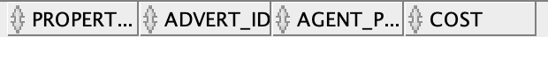

This query below is to check whether there are any illegal and null values in the property feature table.

The result shows no such values.

This query below is to check whether records of property_id in property feature table that are not in the property table. And to check whether the feature_code in property feature table that are not in the feature table.



The result shows that there are no such values.

This query below is to check whether there are any duplicated records in the rent table.

The result shows that there are no such record.



This query below is to check whether there are any illegal and null values in rent table.

The result shows that there are 50 rows of records that contains illegal and null values.

This query below is to check are there any records of agent_person_id and client_person_id in rent table that are not in person table. And are there any records of property_id in rent table that are not in the property table.

The result shows that there are no such records.



This query below is to check is there any duplicated records in sale table.

The result shows that there are no such records.

This query below is to check whether there are any illegal or null values in the sales table.

The result shows that there are 50 records of sales that contains illegal or null values.

This query below is to check are there any records of agent_person_id and client_person_id in sale table that are not in person table. And are there any records of property_id in sale table that are not in the property table.

The result shows that there are no such value.



This query below is to check are there any null or illegal values in the state table.

The result shows that there is one record of null value.

This query below is to check are there any null or illegal values in the visit table.

The result shows that there are no such records.

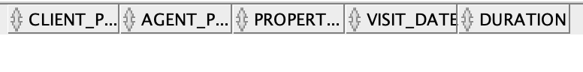

This query below is to check are there any records of agent_person_id and client_person_id in visit table that are not in person table. And are there any records of property_id in visit table that are not in the property table.

The result shows that there are no such records.



**Clean data:**

After detecting errors in the previous process. The following detection strategy is applied to clean the error.

--------------------------------------------------------------------------------

-- Error 1: Duplicate record in ADDRESS table

--(39 out of 13204 records were redundant)

-- Detection Strategy:

-- Solution:



-- Error 2: Dirty record in Agent table

--(There are 0 and negative values in MonRE.Agent)

-- Detection Strategy:



-- Solution:

-- Error 3: Dirty record in Client table

--(There is negative value in MonRE.Client and there are maximum budget that are smaller than minimum budget)

-- Detection Strategy:



-- Solution:

-- Error 4: Dirty record in Person table

--(There are 4 duplicate values in MonRE.Person, we will just keep 1 record in the database)

-- Detection Strategy:



-- Solution:



-- Error 5: Dirty record in Person table

--(There is one person with no title, no name, no email, and meaningless phone number in Person table)

-- Detection Strategy:



-- Solution:

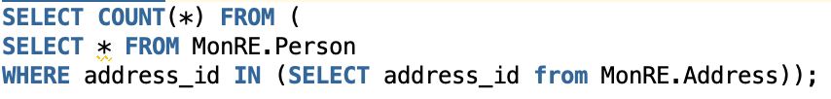

-- Error 6: Dirty record in Property table

--(There is 4403 records with no property size value in Property table, we will simply set it to 0 showing that it is not availabe)

-- Detection Strategy:



-- Solution:



--Error 7: Dirty record in Property table

--(There are 20 redundant records in Property table, we will keep it distinct in the database)

-- Detection Strategy:



-- Solution:



-- Error 8: Dirty record in Rent table

--(There are 1637 records without client_person_id, rent_start_date, and rent_end_date in Rent

-- table. In terms of integrity, we will delete it from the database)

-- Detection Strategy:



-- Solution:

-- Error 9: Dirty record in Sale table

--(There are 2009 records without client_person_id, sale_date in Sale table. In terms of integrity, we will delete it from the database)

-- Detection Strategy:



-- Solution:

-- Error 10: Dirty record in State table

--(There is 1 record without state_code in State table. In terms of integrity, we will delete it from the database)

-- Detection Strategy:



-- Solution:

